./file.sh
awk -F':' '{print $1}' /etc/passwd (It is more advanced than cut, because cut works with data having proper separation but this aws have many options and do the complex separation)
cat /etc/os-release
cat filename
cd
cd ~(with ~ takes to home)
cd <directory_name>
clear
cp -r dev bakupdir/
CTRL + H
cut -d: -f1 /etc/passwd (shows particular column by doing the separation base on the -d which is delimiter i.e. : here and -f1 which is field 1 and the file name but this need proper separator)
df -h (shows the hard disk partition utilization
df -h > /dev/null (if you don’t want the output to be stored and on console put it into the null file which will just for dump but if you try to print the output of it there is nothing will be there like cat /dev/null we can also use this to empty the file like cat /dev/null > /tmp/sysinfo.txt then try cat /tmp/sysinfo.txt)
echo "Hello" (It is a print command)
free -m (shows the memory utilization)
free -m | grep Mem
freeee -m (1 or 2 or &)> /dev/null (here the error comes which are standard errors by default there is 1 which is standard output we can use 2 for standard output error & for both)
file filename(file yum, file /bin/pwd, cd /dev/ls -l you will get all file types here)
find /etc -name host* (Searches file in etc directory with file name contains host as a starting )
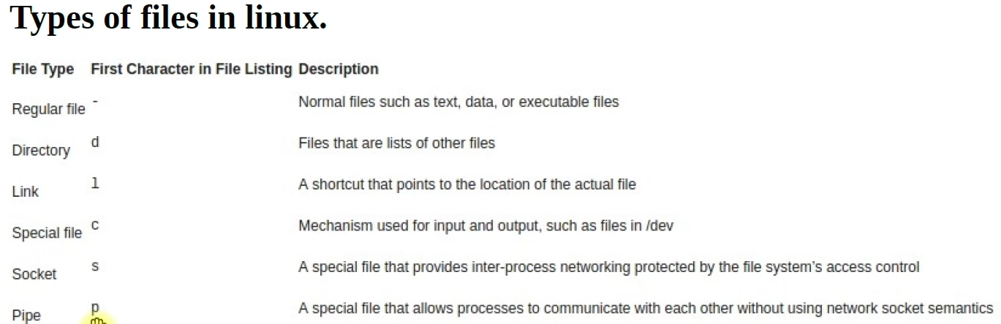

grep username test.txt – full match or partially match but case sensitive
grep -i username test.txt - Ignores the case sensitivity. Even partially matched.
grep -i username < test.txt – Internally the < symbol is used for the above commands no need to mentioned it explicitly it is called input redirection.
grep -i firewall * - search in all files in the current directory not in sub directory.
grep -ir firewall * - search in all files and directory as well, in the current working directory.
grep -ir SELINUX /etc/* - to search the given word in etc directory whether it can in any file or subdirectory.
grep -iv firewall test.txt – it search the word except firewall. Without case sensitive
groupadd devops
history
head test.txt (shows first 10 lines default)
head -20 test.txt (shows first 20 lines)
hostname -I
ip addr
ip address
id <username>
ls
ls -a
ls -al or ls -la
ls -l
ls | wc -l (Here if you want to count the number of files using wc -l we can use pipe operator where left side output is an input for right side)
ls | grep host (here ls will generate the list and then using grep we will find the file with name host)
ln -s /opt/dev/ops/devops/test/command.txt cmds (unlink cmds – to unlink or you can remove the location of the file)
less test.txt (shows content of a file in less you can move the cursor up and down and if you want to search something you can use / in it)
more test.txt (shows content of the file but only moves down using only enter key not up and down arrow and also want to quit in middle press q or reach to the end of the file.)
mkdir directory_name
mkdir testdir{1..5}
mkdir /opt/dev/ops/devops/test – It will not create any folder it will give error
mkdir -p /opt/dev/ops/devops/test – It will create the entire hierarchy.
mv *.txt textdir/
mv devopsfile3.txt /ops
nano filename
pwd
passwd <username>
rm -r *
rm -r directoryname
rm -r filename
rm -rf *
source filename
ssh username@ipaddress
sudo -i
sudo chmod +x filename
sudo dpkg -i <deb_file>
sed ‘s/word you want to replace/word with which you want to replace/g’ * or *.txt – but it changes temporary if you want it permanent the use following command
sed – i ‘s/word you want to replace/word with which you want to replace/g’ * or *.txt
touch "File One.txt" "File Two.txt" "My Report with Data.doc"
touch devopsfile{1..10}.txt
touch filename
touch filename1 filename2
tail test.txt (last 10 lines default)
tail -20 test.txt (last 20 lines)
tail -f test.txt (it shows the dynamic content like log files, after the command it will be in execution
tail -20 /var/log/messages | grep -i vagrant mode only you want to exit from it press ctrl + c)
uptime
uptime > sysinfo.txt (the > takes the output and paste it in the file, if the file is present then overwrites it otherwise creates a new file.)
uptime>>sysinfo.txt (>> this appends the result to the previous result if present in the file.
useradd jenkins
usermod -aG devops ansible (adding user ansible in devops group to and here G is for secondary group where g is for primary group to check it is added in group use -- id ansible)
vim –version
vim filename
vim file commands (:w - save, :q - quit, :wq – save & quit, :q! – force quit, :wq! – force save & quit, :set number, %s/word you want to replace/word which you want replace with --- but this will replace only one word in each line if you want to replace a word everywhere the use, %s/word you want to replace/word which you want replace with/g --- g here for global )
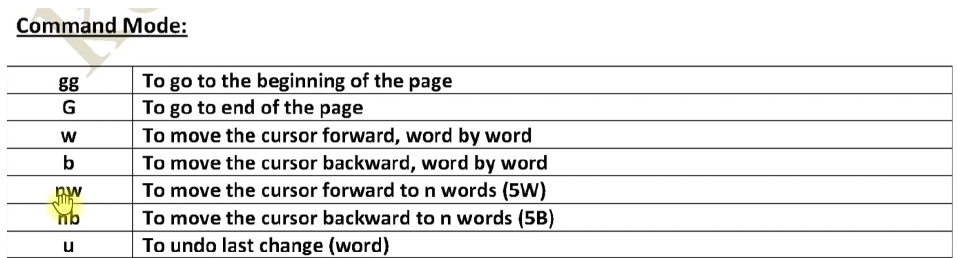
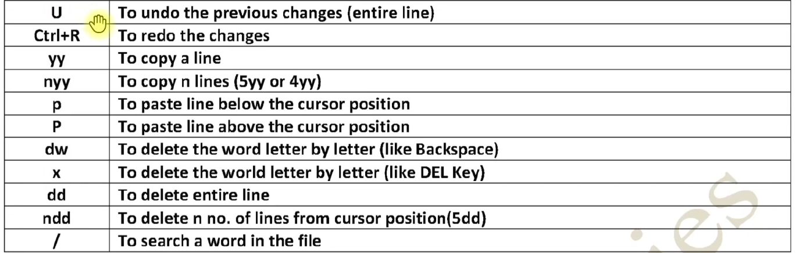
vagrant box list
vagrant destroy
vagrant global-status
vagrant global-status --prune
vagrant halt
vagrant init centos/stream9 --box-version 20250210.0
vagrant reload
vagrant ssh
vagrant status
vagrant up or vagrant up –provider=virtualbox/vmware
vagrant –version
ls `/.vagrant.d/ (Shows home directory hidden file of vagrant.)
whoami
wc -l test.txt or wc -l < test.txt (count the number of line)

